Volunteer report by Jente Beke
European solidarity corps volunteer at Verein StudentInnenkinder
from September 2023 to July 2024

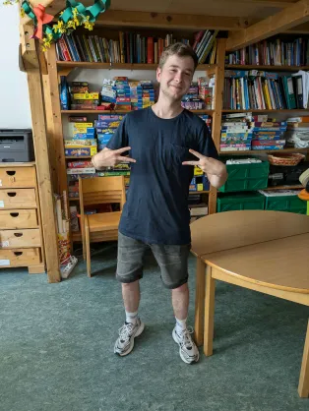
I volunteered in Austria with the European Solidarity Corps. I worked in a hort (after-school care centre). My main tasks were helping kids with homework, organising activities, and assisting the pedagogues.
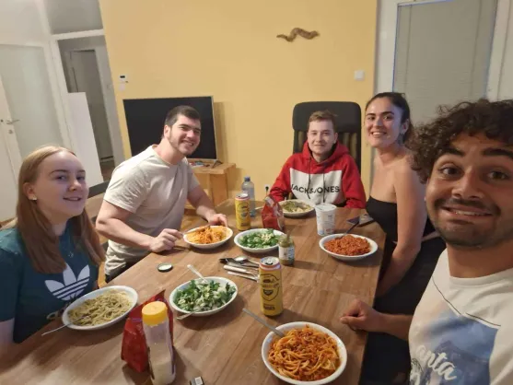
Before my volunteering, I was very stressed. I had never lived abroad or alone and didn't know what to expect. I had worked for two years at a pet store and really wanted to try something new. My mum saw something about ESC and immediately told me about it. We went to an information meeting, and when it ended, I was immediately sold. My girlfriend was going to study in Vienna, and I thought I could maybe find a volunteering job there as well.
During my volunteering, I learned a lot. Not just about working with children but also about living on my own for the first time.
I experienced personal growth and built strong relationships, especially with my two flatmates, but also with other volunteers and with Camillo and Astrid (the two others working in the hort). Their support made my time in Austria unforgettable.
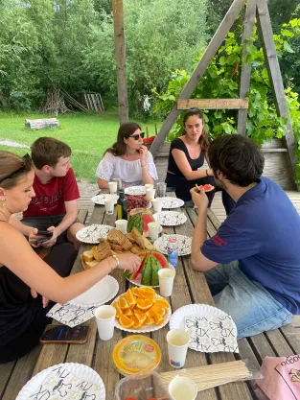
The best thing about my ESC volunteering experience was making a positive impact on the kids' lives while growing personally. Seeing them happy when I helped them with their homework or making them smile with some jokes made me very happy as well. The skills and memories I gained are invaluable.
For me volunteering means giving back, gaining new perspectives, and growing as a person. It's about making a difference, no matter how small, and connecting with people from different backgrounds.
I would recommend participating in an ESC volunteering project because it's a unique opportunity to develop personally and professionally, meet amazing people, and make a positive impact. It's an enriching journey.
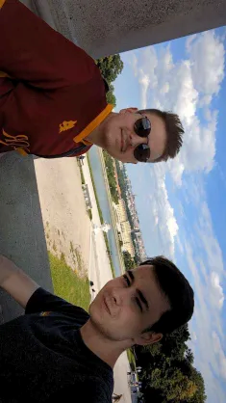
My advice to the next volunteers is to embrace every moment and be open to learning. I wish I had tried to learn more German at the beginning. Don’t hesitate to ask for help, and take time to explore and immerse yourself in the culture.
When I arrived, I was very stressed and unsure. Now, I feel enriched, confident, and grateful for the experience. Working in a hort and living in Austria has been the most fun and rewarding year of my life. I will really miss the children and the wonderful friends I made.

