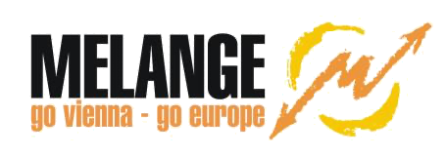**Volunteer report by Sude Özan**

**European solidarity corps volunteer at Kindergruppe Gatschhüpfer from 01.10.2023 to 30.06.2024**

I feel very grateful about spending 9 months in Vienna, working in the beautiful outdoor kindergarten “Gatschhüpfer”. As a very outdoorsy person, I truly loved my workplace. We were in nature with the kids all the time; either staying in our garden area or hiking in the forest. Observing the kids in a free space like this was so valuable for me. It was not a usual place where there were many rules to follow, the idea was based on the uniqueness of every child and observing them with little guidance. Although it was very unusual for me to see the kids with tools like hammers, knives, or nails during the first days, I realized over time that trusting the kids is part of the process. Although the kids were only 3 to 6 years old, they were making fire and chopping wood every day. Especially during those cold snowy winter days, they showed how much resistance they have. As someone who is not used to cold weather like this (in the area where I work it was always colder than the city), I can say that I have learned how to wear properly and adapt to the weather in Austria :)

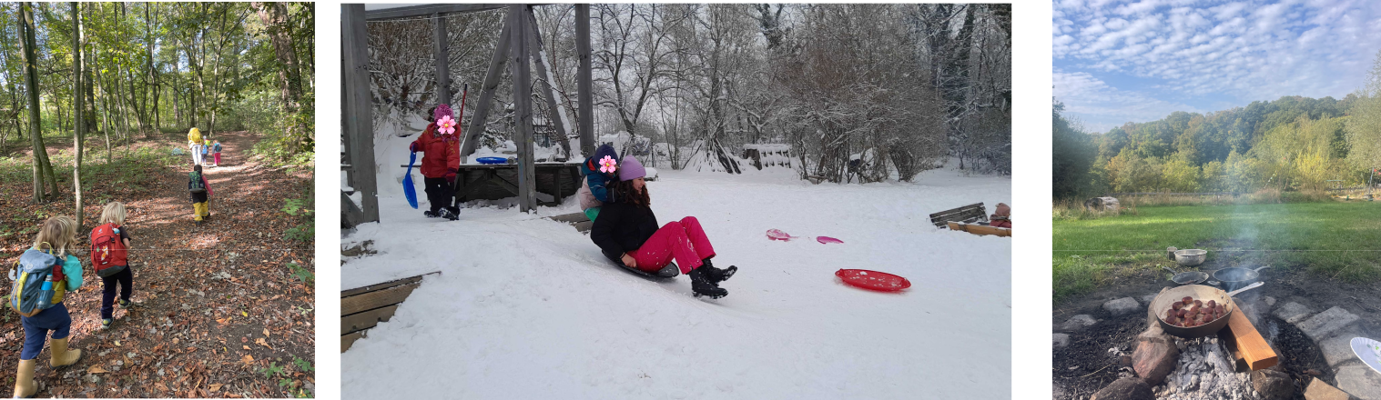

Our usual hikes in the forest Enjoying the snow with the kids My workplace

My coworkers were so friendly with me, and also so wise about nature and plants. Not only did they show kids how to be kind and respectful to nature, but they also taught them a lot about which plants to eat, the names of the mushrooms, and how to find some special kinds of plants to make tea. Making the kids learn about the healing power of nature at that early age was very encouraging. Combining the stillness of nature and the unlimited energy of kids was super mindful. Because kids are the masters of mindfulness, they are always in the moment, so it was a great practice for me to work with kids in the forest. At the end of this volunteering period, I admire nature even more.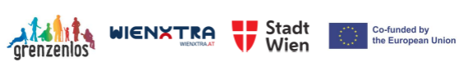

About my social life, our organization Grenzenlos provided many activities/ events with other volunteers. We created our social circle with people from very different cultures and backgrounds. We were all trying something new, something exciting; so we all shared our journey. National Agency organized on-arrival and mid-term meetings where we stayed in hotels in different cities. It was also a great opportunity to meet with volunteers outside of Vienna. Learning German language, although it’s not the most fun language to study, was also one of the other pluses. In addition, Vienna is a great place where you can find almost everything you look for in a city. The best part I love about Vienna besides its history, museums, architecture, great cafes, and swimming in Donau is its parks; they are great places to disconnect from the city, go for a run, or just lie down on the grass and watch the sky. These were my favorite things to do during 9 months.

I believe that as young people, we should get out of our comfort zones, and see that there are so many different lives to live. Trying new things and challenges will always boost our personal growth. My advice to next volunteers is, to go for it and enjoy every experience you have. You will not regret this volunteering experience ;)

