Volunteer report by Gaia Rizzi
European solidarity corps volunteer at Kindergruppe Teddybär
from October 2023 to June 2024

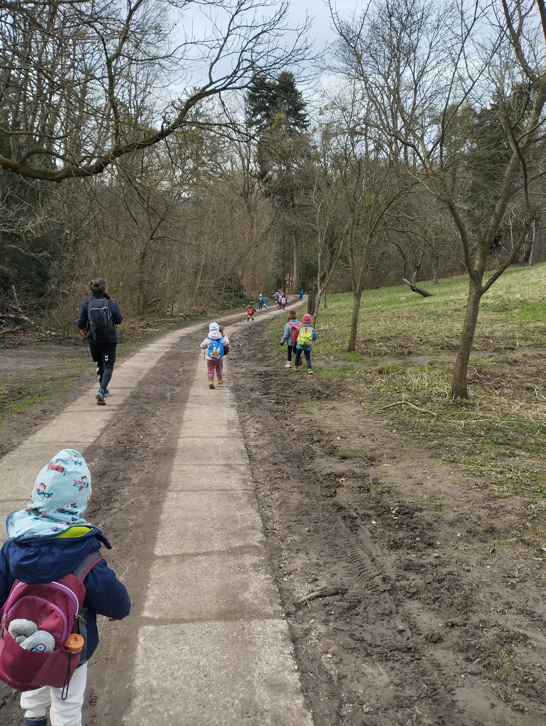
I volunteered in the Kindergruppe Teddybär for nine months. My tasks included mainly supporting the KindergruppebetreuerInnen in their daily activities with the children, preparing the snacks in the morning and afternoon and helping in the kitchen during lunch time. This experience was really useful for me because I learned more about childcare work and gained more problem solving skills and competencies in the educational work with children from 2 to 6 years. As an educator myself, it was really important for me to learn from the pedagogues and observe how they are working. Furthermore, I have improved my language skills both in German and English.

One special moment at the project was when the children finally began to ask for my help and ask me to play with them. In these moments I really felt part of the Kindergruppe.

The best thing about my European Solidarity Corps volunteering experience was to get to know all the other volunteers and spend time with them. It happened a lot during these months and we were able to support and help each other, but also to do fun activities together, discovering Vienna and also travelling to other places.

I would recommend participating in an ESC volunteering project because it’s the perfect occasion to live an unforgettable experience in an other country, discover new things about other cultures and places but also about themselves. Furthermore, this experience helps you to grow as a person and to understand what to do in the future.



