European Solidarity Corps volunteering at MA11
What are the shared flats of MA11 and who is living there?
In a shared flat of a MA11 WG is place for eight Children in the range of 3 years up to 18 years. The group is mixed gender. At the moment there are eight children in the age between 9 years and 16 years living in the WG Am Spitz, five boys and three girls. They live there the full year and so they live together like a family, even though they all have their own families somewhere in Vienna. A view of them go home to the parents on the weekend or for a view weeks at the holiday. It depends on the possibilities of there prim families. The reasons why the live in a shared flat is quite different. Therefore, the four social pedagogs, who take care of them, are doing all things with them, what normally parents do with their children. So they do with them all the stuff for a good school education, finding a place for work when they old enough, looking for their mental health, doing things what children want to do in spare time, celebrate what should be celebrated and so on.
If possible, a return to the family (of origin) is to be worked on. If it is possible, we involve the parents into the education of their children.
The aim is the emancipation of the child/adolescent and the acquisition of resources that enable a way of life in self-organization and independence. The ability to make decisions, to act and to participate are expended and disadvantages/deficits are reduced.
At this time there are three female social pedagogs and one male who works with the children over the year. Per day, there is one of them about 24h who live together with them. They stay there also over the night. The shared flat works the full year, 24h/ 7 days per week. From Monday to Friday, there is another person who helps to keep the flat clean, makes the laundry, go for shopping and helps to cook the food, and so on.
The shared flat called MA11 WG Am Spitz is located in the 21 district of Vienna, a district close to the Danube. The shared flat is close to a central railway station, so it is easy to get anywhere in Vienna. In the Danube there is a small, but very long island ( 21 Kilometer) where the people from Vienna can relax and do there sportive things. So on this island there are no cars allowed, so there is the good possibility for cycling, inline skating or run and walk as you like. There are spaces where you can do outdoor things what you want, like at a huge park. In addition, swimming is also possible.

Proposed activities
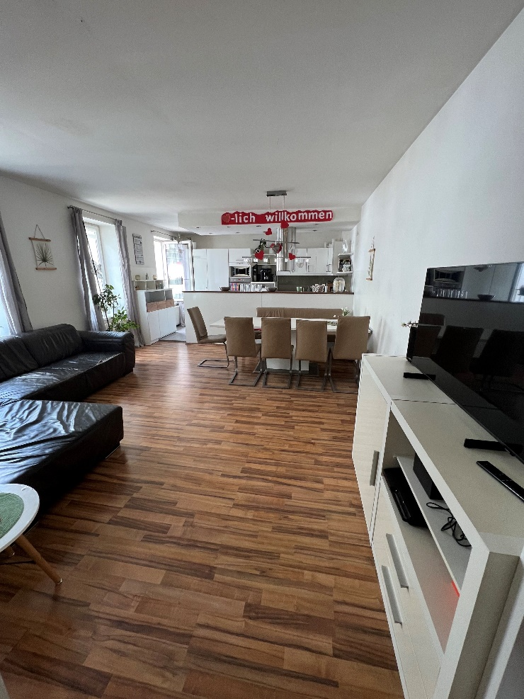
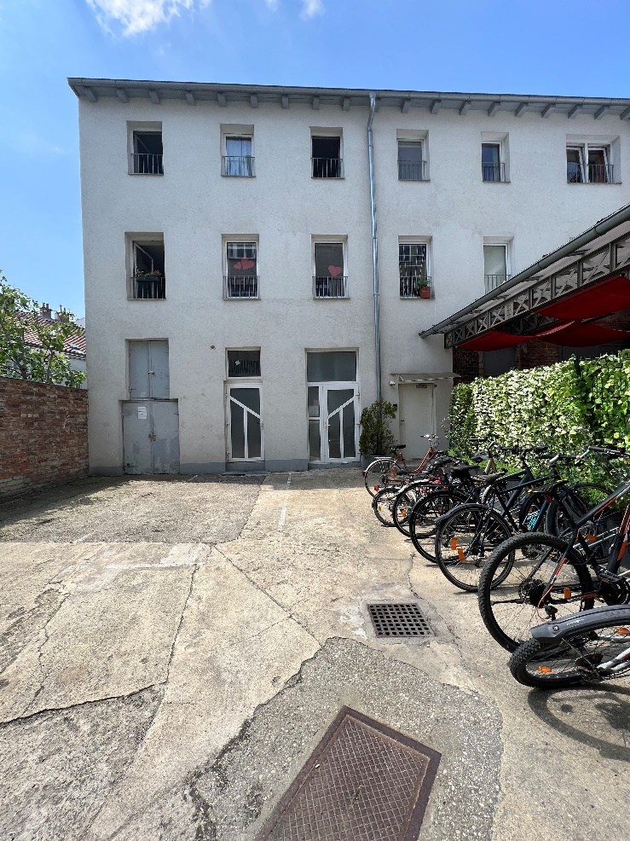
A volunteer should help the team, in all possibilities, to help the children in their development. This means help them at the schoolwork and do things in the spare times whenever it is possible. Keep them save on the ways they have to do, for example going to a doctor and bring them to the football training for example.

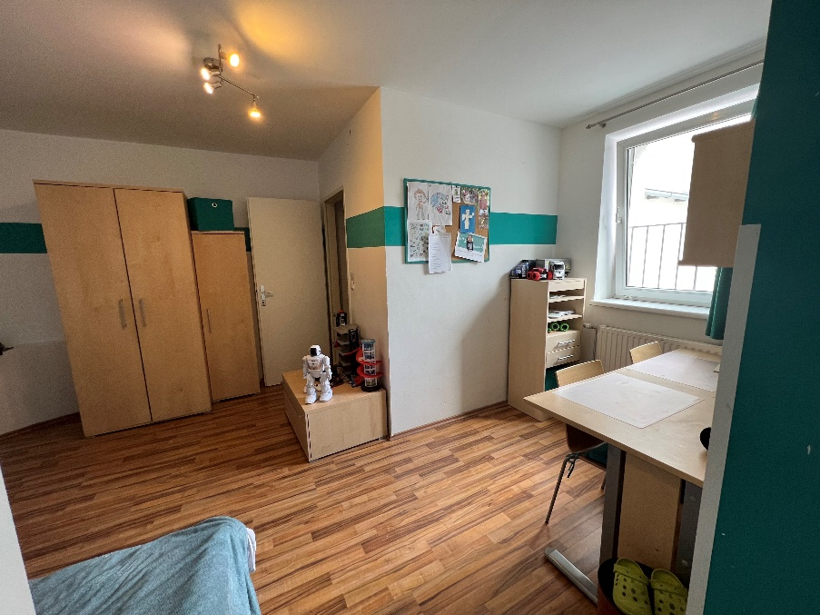
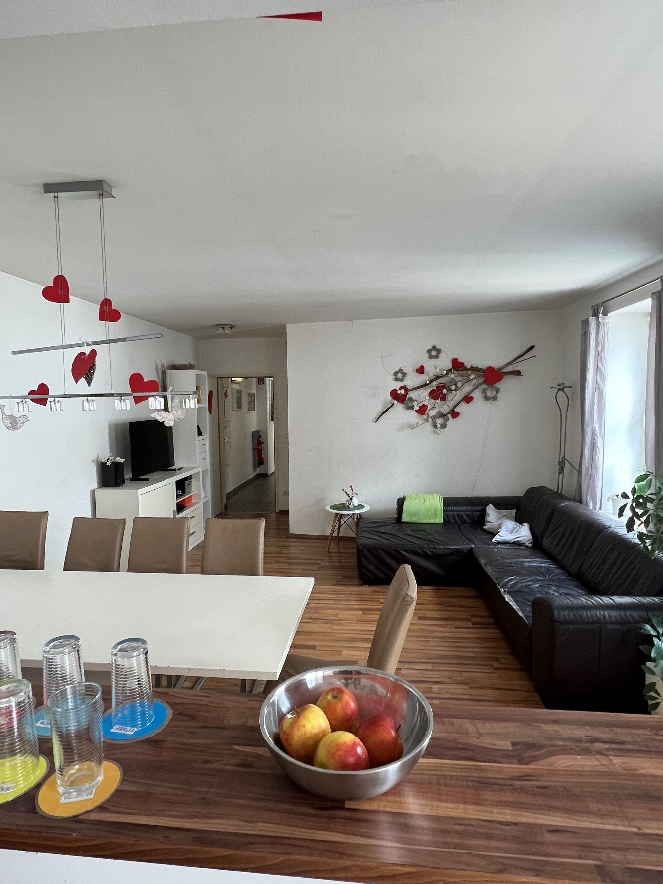
This European Solidarity Corps (ESC) project in Vienna is coordinated by the association Grenzenlos within the MELANGE program. If you want to apply for this project, please fill in the Melange application form and send it together with your CV (curriculum vitae) and motivation letter to application@melange.wien
Please state the name of the ESC project (host organisation), that you would like to apply for, in the subject of your e-mail. Grenzenlos will forward your documents to us, the hosting project, where the selection will be made.
Important! Your application will only be accepted if it is complete and if you already have a supporting (sending) organisation.
All ESC placements coordinated by Grenzenlos are generally available to everyone between the age of 18 and 30 who is residing in an ESC program or partner country. However, in the selection procedure a preference is shown for candidates with fewer opportunities. You will be informed about the outcome of the recruitment process after the application deadline. For more information, please visit www.melange.wien

