European Solidarity Corps volunteering at MA11
What are the shared flats of MA11 and who is living there?
We are a youth and welfare organization that contribute to supporting the rights of children and adolescents to promote their development and upbringing as independent and socially competent individuals, to protect them from all forms of violence and to strengthen the educational power of families.
We are a social-pedagogic institutions that provides residential care for 8 children/adolescents with professional care in flats.
Most of the kids at the WG Käthe Dorsch Gasse are in between 6-12 years old. We have five girls and three boys. The majority of the group is around 10 years old and lives together for almost five years or longer. It is a very friendly and stable group environment. The children are very curious and like to meet new people. Only a few of them have regular contact with their families. Most of the kids are living full time at the WG, also on the weekends. During the week, they go to school, do their homework, and enjoy their free time. They are being cared for 24/7, like in a normal family.
A team of five people is responsible for the well-being of the children. They have a professional education in social work. They work in shifts. Every day 1 or 2 team members are present for 24 hours, and then a new team member is doing the next day. The team constellation are five women, who are working since 25 years or longer, they are very experienced and have a loving connection with the children who are living there. A female house cleaner, who is also very friendly and loving, supports the team. She is working from Monday to Friday at the apartment. She also is an excellent cook and makes very tasty meals for the children and team members.
Every two weeks we have team meetings, where the head of facility is also present. We are discussing the development of the children, how the relationship with their families are evolving and what kind of supportive measures we have to install for the children and their families. The volunteer should join these meetings at least once a month.
The WG Käthe Dorsch Gasse is located in the 14 district, which is known for its green environment and outdoor possibilities. It is a brand new apartment, the children are moving in July from Klosterneuburg /Lower Austria into the apartment. Therefore, everything is new for the kids, a new school, new location, new parks, etc.. The apartment is newly arranged and beautifully furnished. Every child has its own room, two of the boys are sharing a room. We are still decorating the new flat, therefore we have no pictures yet. The WG Käthe Dorsch Gasse has a lot to offer, because we have a playground in the inner courtyard. Nearby are also a lot of playgrounds and a zoo to visit with the kids.

Proposed activities
As a volunteer, you are integrated in the everyday life of our children. You would be a member of the team, which means that you are an example for our children and take responsibility for their well- being. You would help bringing the kids to their schools, therapy and free time activities. You would initiate to play and interact with the children, inside and outside of the WG. You would also help preparing dinner or lunch boxes for the children, sometimes going to the supermarket or clothing stores to shop necessities with them. Depending on your language skills and independence / personality, we will decide on how much responsibility we can give you regarding the children we have to take care for.

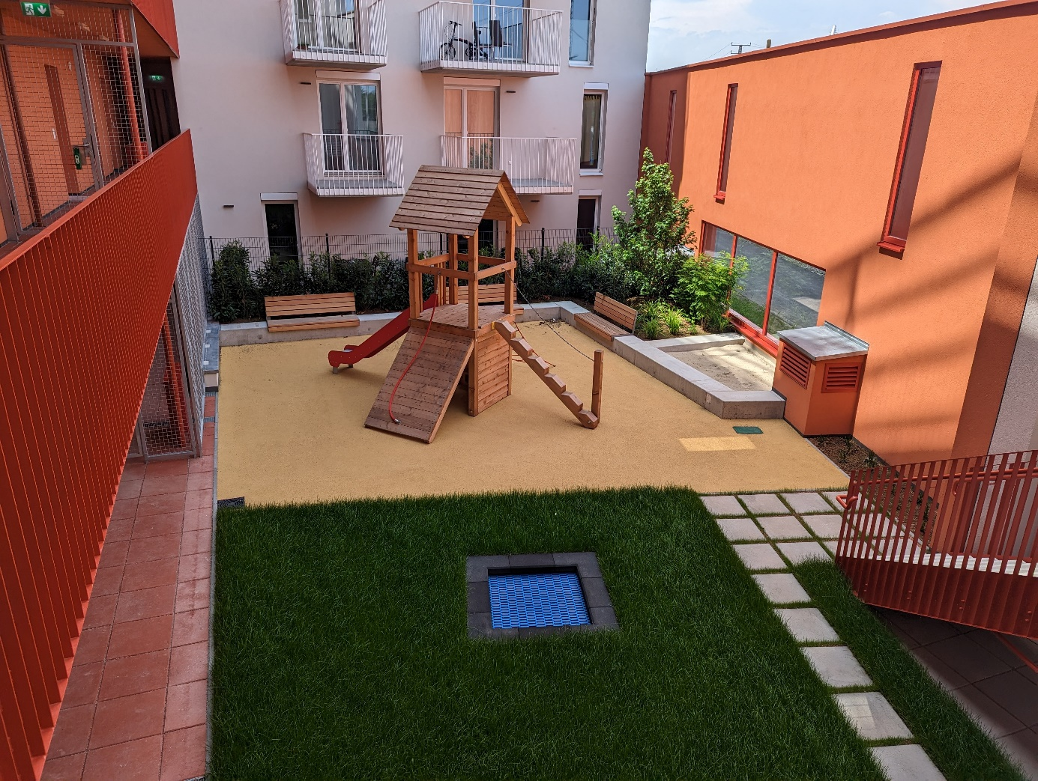
This is our indoor playground, more pictures are coming soon .

This European Solidarity Corps (ESC) project in Vienna is coordinated by the association Grenzenlos within the MELANGE program. If you want to apply for this project, please fill in the Melange application form and send it together with your CV (curriculum vitae) and motivation letter to application@melange.wien
Please state the name of the ESC project (host organisation), that you would like to apply for, in the subject of your e-mail. Grenzenlos will forward your documents to us, the hosting project, where the selection will be made.
Important! Your application will only be accepted if it is complete and if you already have a supporting (sending) organisation.
All ESC placements coordinated by Grenzenlos are generally available to everyone between the age of 18 and 30 who is residing in an ESC program or partner country. However, in the selection procedure a preference is shown for candidates with fewer opportunities. You will be informed about the outcome of the recruitment process after the application deadline. For more information, please visit www.melange.wien

