European Solidarity Corps volunteering at WOHNGEMEINSCHAFT (WOHNHEIM) ST. MARTIN
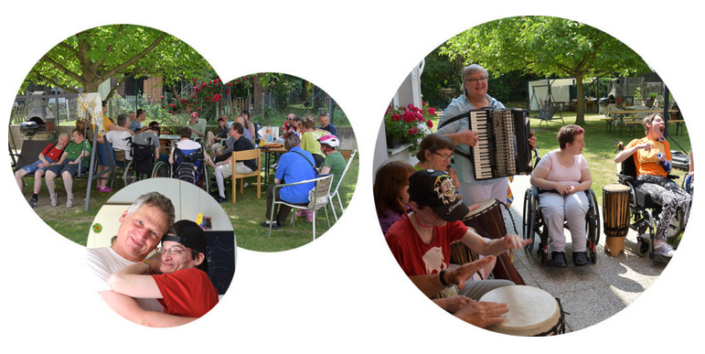
What is the Wohngemeinschaft St. Martin?
St. Martin is a living place for about 25 adults with various disabilities. It is located in Klosterneuburg, a small town near Vienna. We have two living groups/communities and several practice rooms, where the clients (inhabitants of St. Martin) work during the day. Our main task is to offer housing and (re)integration into the society. This is done mainly through leisure time activities and by offering a working place. People are provided training and other practices needed for working.
Klosterneuburg itself is an old town located at the Danube river. You can reach the city centre of Vienna by public transport within 30 minutes. It is surrounded by the Vienna Woods (Wiener Wald), which offers great opportunities for hiking, walking and other outdoor activities.
As a volunteer, you would live at St. Martin, too. This means you are provided meals together with the staff and the clients. Special food arrangements (e.g. vegetarian) are no problem. Exceptions or special arrangements regarding the house rules can be made on an individual basis. Please note, that the rooms are non-smoking rooms (fire alarm) and that you have to register guests with the project leader.
Proposed activities
Our experiences with international volunteers in the past years have been good. As a volunteer, you can deliver valuable input to our work, especially concerning our leisure programme. So you enable the clients to make more excursions, sports, individual shopping or to do other things that normally would not be possible to a larger extent. Your working time will be fulfilled with some of the following activities:
- Give new inputs to our afternoon program
- Develop an own project, according to your interests, e.g. arts or music.
- Support the staff and the clients with the daily program and activities (e.g. help the clients to cook, with eating, cleaning the common room, to dress or watch TV together; maybe your are asked to help out with the personal care of the clients)
- Develop your own ideas as an extension of our leisure time and afternoon program.
- If you like, make excursions with one or two clients
- Attend the team meetings
The relation between daily activities and personal project will depend on your project, but about 50% will be daily activities. You will work between 30-38 hours on 5 days per week. The specific working days will be agreed with your host team.
A regular day looks may look like this:
4 – 7 p.m.: leisure time activities – going for a walk, playing games, doing some gardening, sports, doing shopping with the clients
7 – 9 p.m.: helping to prepare dinner and evening toilette of the clients.
Saturday and Sunday you are involved in the activities from 10 a.m. to 8 p.m.

Your profile and Recruitment Process
Since this project is dealing with disabled people, you should be willing to and enjoy work with them. Open-mindedness will help you in any situation. The working language in St. Martin is mostly German and English. Before you start, no language skills are required, you will be invited to attend a German course during your project.
This European Solidarity Corps (ESC) project in Vienna is coordinated by the association Grenzenlos within the MELANGE program. If you want to apply for this project, please fill in the Melange application form and send it together with your CV (curriculum vitae) and motivation letter to application@melange.wien
Please state the name of the ESC project (host organisation), that you would like to apply for, in the subject of your e-mail. Grenzenlos will forward your documents to us, the hosting project, where the selection will be made.
Important! Your application will only be accepted if it is complete and if you already have a supporting (sending) organization.
All ESC placements coordinated by Grenzenlos are generally available to everyone between the age of 18 and 30 who is residing in an ESC program or partner country. However, in the selection procedure a preference is shown for candidates with fewer opportunities. You will be informed about the outcome of the recruitment process after the application deadline. For more information, please visit www.melange.wien and the European Youth Portal

