European Solidarity Corps volunteering at “StudentInnenkinderhort”
What is the StudentInnenkinderhort?
The StudentInnenkinderhort is organized by the “Verein StudentInnenkinder” (Association for Students´ children) and located in the AKH Campus (University Campus in the 9th district in Vienna). It is divided into a kindergarten and a day nursery (Hort) for children between the age of six to ten.
We believe that only in a respectful environment, a child can develop his/her full self and his/her creativity. In our long history, we build on and continue the tradition of an education without fear of authorities to ensure that the education of humanity continue to succeed.
As a volunteer, you will work at the Hort. The opening hours of the Hort are Monday to Friday from 12 to 6 p.m., this will be your working hours as a volunteer.
Proposed activities
During the opening hours a volunteer should be present and interact with the children. You bring your own knowledge and experience from your cultural background. This can be music, dance, tales, cooking receipts, games, sports etc. According to your personal preferences you make the children familiar with your background. Generally, a volunteer’s work consists of the following:
- Work with the children in their leisure time
- if necessary: help with the homework
- Attend the regular program meetings of the staff and the children, where the programme of activities is discussed and defined
- Be part of the team: team meetings, once per week and meetings with parents once per month
An afternoon starts with a common meal, cooked by our own cook, followed by 1-2 hours where the children do their homework. After that, the leisure time activities start: mostly outdoors, also indoors if the weather is not nice. During the opening hours, two members of the full-time staff are always present. This means that you will never be let alone with the children.
Leisure time activities can be:
- Sports, such as swimming, football, gymnastics, ice skating. (depending on the time of the year); if you are specialized in a certain sport, it would be great, if you could teach the children; sports activities are always on Tuesday
- Creative workshops like painting, drawing, baking cookies or practising for a theatre play
- Children can also play for themselves

You can participate in the existing program but also suggest and lead activities, workshops, etc. yourself (with support of the staff) on a topic with which you are familiar and interested in.
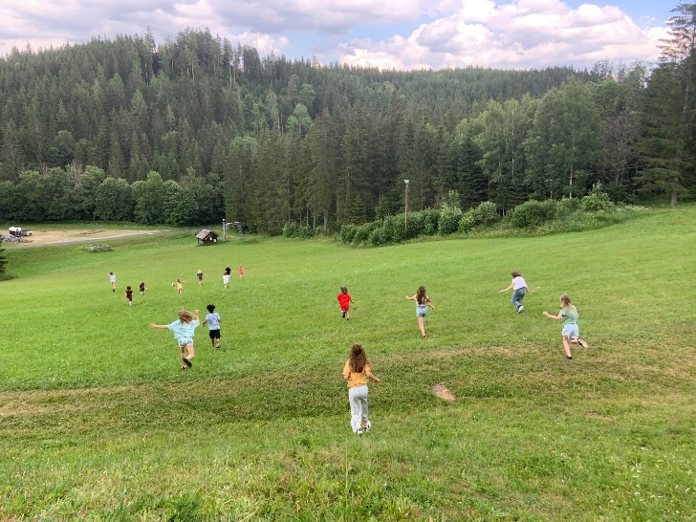
Two weeks per year (winter and summer) there is a holiday excursion outside Vienna. During this time, you will support the staff to create a good time for and with the children. The activities depend on the season and weather: hiking/skiing, swimming, barbeque etc. You can help prepare these weeks, e.g. inventing games and activities, help with practical organisational matters or cooking together with the kids and staff. The excursion will also be an opportunity to see other parts of Austria.

Volunteer profile and recruitment process
No specific skills are needed. The volunteer should in general be openminded, interested in sports and outdoor activities and enjoy working with children. A creative spirit, good communication and language skills can be of advantage but are not necessarily needed. You should be motivated to learn German though.
This European Solidarity Corps (ESC) project in Vienna is coordinated by the association Grenzenlos within the MELANGE program. If you want to apply for this project, please fill in the Melange application form and send it together with your CV (curriculum vitae) and motivation letter to application@melange.wien
Please state the name of the ESC project (host organisation), that you would like to apply for, in the subject of your e-mail. Grenzenlos will forward your documents to us, the hosting project, where the selection will be made.
Important! Your application will only be accepted if it is complete and if you already have a supporting (sending) organization.
All ESC placements coordinated by Grenzenlos are generally available to everyone between the age of 18 and 30 who is residing in an ESC program or partner country. However, in the selection procedure a preference is shown for candidates with fewer opportunities. You will be informed about the outcome of the recruitment process after the application deadline.
For more information, please visit www.melange.wien

