European Solidarity Corps volunteering at Naturkindergruppe am Himmel “Gatschhüpfer”

About Naturkindergruppe am Himmel “Gatschhüpfer“

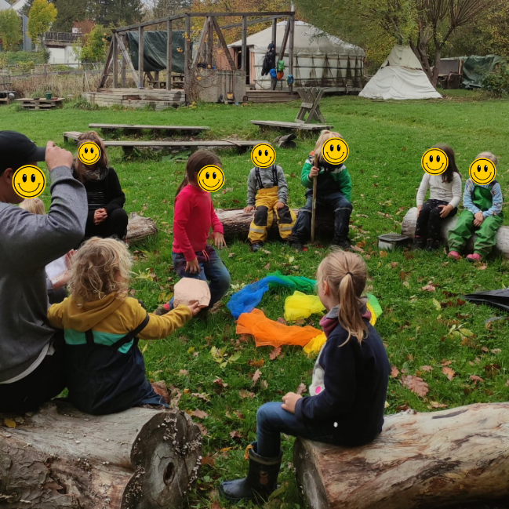
The "Naturkindergruppe am Himmel - Gatschhüpfer '' is a small outdoor kindergarten in the hills around Vienna, totally embedded in nature. It is a non-profit organization run by the parents of the children attending the kindergarten. The idea of the organization is based on a humanistic philosophy. We live diversity, are open minded to different cultures, religions, and rainbow families. The main targets of the teachers are to build up an individual relationship with the kids and to respect and take the individual needs of the kids. Our meaning of education is more to accompany the children and help if they need it, but not to lecture them. Each child is accepted as an individual, encouraged to develop self-consciousness and self-confidence.

The main focus of our kindergarten is on being in nature. The kids spend most of the time outside, in the woods and fields around or in their own kindergarten "garden". Besides the kindergarten building the kids have a Mongolian yurt where they can have shelter in case of heavy rain or really cold weather.

There are a maximum 14kids/day between the ages of 2,5 and 6, and two teachers looking after them from Monday to Friday from 8:15 am till 4:00 pm. The kids are picked up form the teachers at a meeting point at two different public transport stations in the city and then go up in the Viennese hills to their kindergarten by public transport (20 minutes). We regularly host volunteers, and the pedagogues offer caring experience in accompanying them. Also the kids are used and open to “newcomers”. The parents are involved in the daily life of the kindergarten, for example once a week for a cooking service or for everything that is needed to run a kindergarten, like buying material for handicraft work, snacks, looking after the yurt, the garden, organizing, etc. The "Gatschhüpfer” children’s group offers a family like environment for the kids and the staff.
Proposed activities
Our kindergarten is open from Monday to Friday from 8:15 to 16:00 and we would like you to participate as a volunteer in our daily routine from 8:15 to maximum 15:00. On Fridays you will finish earlier, and you will have a break of half an hour at lunch time each day.
A typical day can look like this:

8:15 meeting kids and teacher; accompanying kids to the starting point at “Cobenzl” up in the Viennese hills by public transport
8:40 walking through nature to the kindergarten building (minimum 15 minutes to 4 hours, depending on the route and the plan of the day, discover nature, do activities together, etc.
9:00/9:30 snack somewhere in nature, kids have their own snack with them
12:00 lunch time (we have a cook, on Fridays parents prepare the lunch)
After lunch the kids will repose, reading, playing silently, or are picked up by their parents (especially the smaller ones)
13:30/14:00 go outside in the kindergarten garden and to the yurt, play, read, do handcrafts
14:30/15:00 have a snack
16:00 closing time, everybody will leave

Your tasks as a volunteer will be to support the pedagogues in their daily work with the kids during the opening hours, and to bring new ideas and activities to the group, according to your interests and skills, and the interests of the children.
You tasks can, for example, be:

➢Accompany the kids by public transport
➢Walk with the kids and teachers to the kindergarten
➢Play, pain, sing, read, do handcrafts with the kids
➢Brin in your own ideas and personality. Plan and realize own activities supported by the team of teachers and parents
➢Help before, during, and after lunch with food and dishes
➢Help prepare the afternoon snack
➢Help parents with some of the organizational tasks depending on your skills
➢Take part in parent meetings and teacher meetings
➢Help to maintain the garden and yurt

Your social and pedagogical learning outcomes will be the following. You will learn how to:
- Observe the children’s play and not to direct it
- Motivate children without lecturing
- Support to solve conflict situations or problems
- Teach kids to do thing by themselves
- Communicate non-violently
- React on kids different life and emotional stages
- See kids as individuals and learn more about their different personalities

Furthermore, you will learn
- How a parental administrated organisation is working
- What different tasks have to be fulfilled to run an organisation
- How democratic communication, planning and decision taking is working in a self-administered organisation
- How to dress in different weather conditions

You will also get to know.
- Austrian culture and food
- Vienna and its surroundings
- The German language
- Different ways of living and thinking
- What kind of plants are growing and what animals are living in the hills around Vienna

Volunteer profile
We are an open minded organisation, we don’t discriminate any applicant because of their gender, religion, sexual orientation, origin, cultural background, etc. The volunteer should
- like working and being with children
- be open-minded
- have an interest in learning and getting to know different cultures, ways of thinking, new languages (German!), and new people.
- be interested in human beings, especially children and treat them with respect and see them as individuals.
- like challenges and be able to reflect on them
- be willing to become part of our organization and to learn from each other.

As we are an outdoor kindergarten you should also
- love and respect nature and
- be weather resistant!
Please inform yourself about the seasons and weather in Vienna, so you are aware what to expect when working in our outdoor kindergarten!

Recruitment process
This European Solidarity Corps (ESC) project in Vienna is coordinated by the association Grenzenlos within the MELANGE program.

If you want to apply for this project, please fill in the Melange application form and send it together with your CV (curriculum vitae) and motivation letter to application@melange.wien

Please state the name of the ESC project (host organisation), that you would like to apply for, in the subject of your e-mail. Grenzenlos will forward your documents to us, the hosting project, where the selection will be made.

Important! Your application will only be accepted if it is complete and if you already have a supporting (sending) organization.

All ESC placements coordinated by Grenzenlos are generally available to everyone between the age of 18 and 30 who is residing in an ESC program or partner country. However, in the selection procedure a preference is shown for candidates with fewer opportunities. You will be informed about the outcome of the recruitment process after the application deadline. For more information, please visit www.melange.wien and European Youth Portal

