European Solidarity Corps volunteering at KULTURHAUS BROTFABRIK

What is KULTURHAUS BROTFABRIK (CARITAS VIENNA)?
www.kulturhaus-brotfabrik.at
https://www.youtube.com/watch?v=-lr6sw1ttH4&t=2s

CARITAS VIENNA counsels, accompanies and supports members of our society who are currently finding themselves in a challenging situation, who are suffering from illness or the consequences of an unfortunate incident or a catastrophe. CARITAS VIENNA assists regardless of the social, national or religious background of the people in need. CARITAS VIENNA runs various departments focusing on different social challenges. One department is the so-called DEPARTMENT FOR COMMUNITY WORK focusing on prevention and ongoing support for people at social risk. The various projects of this department accompany housing units, foster neighbourhood helping networks, support volunteering and tackle social exclusion through community arts. One of the projects run by the department for community work is a culture centre called KULTURHAUS BROTFABRIK.

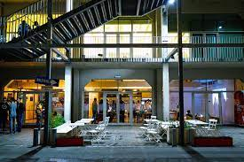
KULTURHAUS BROTFABRIK is a Community Arts project situated in Vienna's 10th district, Favoriten. In this very lively and colourful district of Vienna KULTURHAUS BROTFABRIK offers a wide range of cultural events at two separate venues, in order to create new networks within the local community.

The two main targets of Kulturhaus Brotfabrik are to build bridges between different communities, autochthonous Viennese inhabitants and newcomers with the help of art and culture and to make the arts and artistic expression accessible to people whose access to mainstream institutions of art is limited and/or impeded through societal mechanisms of exclusion.

The main venue of KULTURHAUS BROTFABRIK is situated within the premises of Brotfabrik Wien, an arts and culture area in Favoriten. KULTURHAUS BROTFABRIK aims at linking Brotfabrik Wien to the social housing complexes neighbouring the area and addresses social issues by the means of participatory arts (at least to some extent). KULTURHAUS BROTFABRIK as a whole aims at empowering the neighbourhood by activating individual and collective capabilities/capacities as well as strengthening local structures and networks.
In addition to this specific aim, various projects based within KULTURHAUS BROTFABRIK – e.g. COMMUNITY COOKING, LERNCAFÉ, SUPERAR – focus on easing social tensions prevalent within the district by strengthening solidarity among residents, decreasing social isolation, and fostering social cohesion within the neighbourhood. The initiatives offer and create space and opportunity for the residents to express and experience themselves and become aware of their potentials. KULTURHAUS BROTFABRIK, however, is more than the sum of these initiatives: It’s a community hub that initiates participative processes.

KULTURHAUS BROTFABRIK also operates a second, smaller venue at the main market square of Favoriten, the STAND 129. STAND 129 is right in the middle of the busy centre of the district and offers great opportunities for low-threshold and participatory events.

The work of KULTURHAUS BROTFABRIK focuses on the people living and working around its two venues but other groups are addressed as well. These groups are the main target groups of KULTURHAUS BROTFABRIK:
• Population / people living in the area
• People with a migration background and/or experiences of discrimination
• People who are systematically disadvantaged in the education system
The culture centre KULTURHAUS BROTFABRIK is a hub that transforms individual projects into a space of participatory processes (through art and social design) and engaging the community.

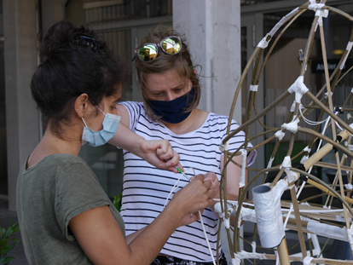
The volunteers will be involved in organising different opportunities for the residents living around KULTURHAUS BROTFABRIK and STAND 129 to interact with each other. Besides supporting existing initiatives (art workshops, repaircafé, concerts, children's events) the volunteers are also encouraged to present their own ideas which they might come up with when getting in touch with the residents.

There are many people working within KULTURHAUS BROTFABRIK and who are split up into different teams. Since KULTURHAUS BROTFABRIK is supposed to be more than the sum of the projects based within its walls, we have been focusing on offering possibilities for the people working at KULTURHAUS BROTFABRIK to network, engage with each other and develop a sense of community. The volunteers will be involved in offering these opportunities as a kind of "feel good managers".

KULTURHAUS BROTFABRIK is also involved in international, EU-funded projects (Erasmus+, Creative Europe). In case of approval of funding for a new project, the volunteers will be involved in supporting these international projects. As there are also plans to submit a new project application for 2024, the volunteers may also be involved in the process of designing an international project. The international working language is English, so the volunteers have the chance to be involved in research activities, the development of concepts and also the communication with the international partners (possibly also participation in partner meetings).

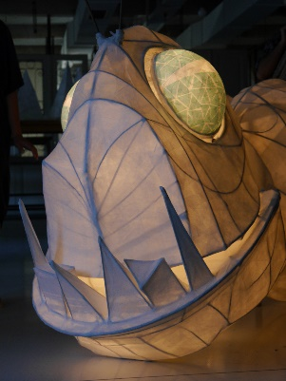
Required Volunteer Profile
You should be interested in community work, (participatory) art and/or graphic design. The potential volunteers should be open to meeting other people, engaging with strangers and building relationships with the residents and visitors of KULTURHAUS BROTFABRIK. We expect the volunteers to command good communication skills, to be capable of working in a team and to be open minded.
According to the interests of the volunteers in combination with already acquired abilities and skills there are several fields of action. The volunteers will find a big variety of tasks, which offer many possibilities to learn by doing.
The fields of action are
- graphic design (illustrations by hand, logo design, Indesign, Illustrator)
- marketing activities like preparing posters, leaflets and the like and distributing them in the neighbourhood
- photography and video documentation of events
- technical tasks / stage hands at events
- involvement in conceptual work surrounding art workshops and participatory art projects
- decoration and maintenance of venues
- coordination of local volunteers

Moreover, since Kulturhaus Brotfabrik will potentially lead a Creative Europe project and is also planning to develop another Erasmus+ application, it is of advantage if volunteers are interested in the following topics:

- Theatre work and methodologies like Devised Theatre and Theatre of the Oppressed
- Antiracism Work
- Gender Justice issues, LGBTQIA+ rights
- Self-representation
- Critical Thinking
- Fundamental Rights of the EU
- Non-formal and adult education
- Participatory methods in project development

During the application/selection process, we will explain in detail the indicated fields of action to the candidates and discuss whether some of them fit into their expectations and to the learning possibility they are seeking for. Together we will decide on the exact tasks they will take on depending on their interests and competencies.
We definitely envisage involving participants who face situations that make their participation in the activities more difficult. Since the fields of action are diverse, we are convinced that it is possible to match the competencies of the candidates and their specific situation with their potential tasks at KULTURHAUS BROTFABRIK, and vice versa.

Application and Selection Process
This European Solidarity Corps (ESC) project in Vienna is coordinated by the association Grenzenlos within the MELANGE program.
If you want to apply for this project, please fill in the Melange application form and send it together with your CV (curriculum vitae) and motivation letter to application@melange.wien
Please state the name of the ESC project (host organisation), that you would like to apply for, in the subject of your e-mail. Grenzenlos will forward your documents to us, the hosting project, where the selection will be made.
Important! Your application will only be accepted if it is complete and if you already have a supporting (sending) organization.
All ESC placements coordinated by Grenzenlos are generally available to everyone between the age of 18 and 30 who is residing in an ESC program or partner country. However, in the selection procedure a preference is shown for candidates with fewer opportunities. You will be informed about the outcome of the recruitment process after the application deadline. For more information, please visit www.melange.wien and European Youth Portal

